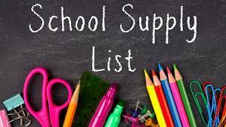

**7th Grade Life Science Supply List**

Ms. Istre (pronounced “East”)- istrekr@boe.richmond.k12.ga.us

**Supplies Needed**

* Blue or Black Pens and Pencils
* Earbuds/earphones (only to be used during specified times)
* 1- one inch binder to be used for science OR you can designate a section for science in a larger binder
* Dividers with pockets (to keep binder organized)
* Loose leaf paper
* 2 Composition books or spiral notebooks (for Science)
* Colored pencils or markers (for at home projects)
* Sturdy Book bag
* Agenda to write down homework. You **WILL** have homework every week.
* Locker Rental- sold during the first 2 days of school for approximately $7.00
* Charged laptop- issued by ARJ to all students during the first week of school

**Wish List of Items for Upcoming Labs/Class Activities: (Donations would be greatly appreciated.) ☺**

Tissues Styrofoam cups, plates, bowls Zip-loc bags

Sanitizer Plastic spoons Masking Tape

Latex/Non-latex gloves Wet Wipes Paper towels

**Great ways parents can help the educator as well as the student:**

* Check grades in Infinite Campus often (Progress Reports & Report Card Grades should not be a surprise). Remember, there are only 2 semesters this year.
* Sign up, read, and communicate through Remind messages
* Read teacher’s ARJ webpages at least once a week
* Sign up as a moderator on Canvas to see some of the work your child is completing
* Do periodic book bag “organization checks”- You would be amazed at the things you will find. ☺
* Encourage and motivate your child daily!